Chapter 11, Solution 84.

- Maximum demand charge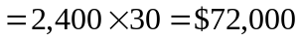
Energy cost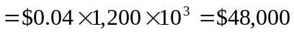
Total charge =

- To obtain $120,000 from 1,200 MWh will require a flat rate of
